**Brooklyn torah gazette**

**For parshas PINCHOS 5783**

Volume 7, Issue 42 (Whole Number 349) 19 Tammuz 5783/ July 9, 2023

**Printed L’illuy nishmas Nechama bas R’ Noach, a”h**

For a free subscription, please forward your request to [***keren18@juno.com***](mailto:keren18@juno.com)

**Rabbi Shalom Mordechai**

**Hakohen Schwadron**

**(The Grandson and the Grandfather)**

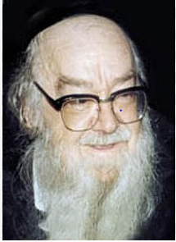

**Rabbi Schwadron (left) the grandson and Rabbi Schwadron the grandfather**

R’ Shalom Mordechai Hakohen Schwadron z”l (“The Maggid of Yerushalayim” born 5673 (1913) – died 22 Kislev 5758 (December 21, 1997) was one of Israel’s senior Torah leaders, who was well known to the English-speaking public through Artscroll’s The Maggid Speaks series.

R’ Schwadron was born in Yerushalayim. His father, R’ Yitzchak, was a noted scholar, and his grandfather, after whom he was named, was the leading posek/halachic authority in Galicia before World War I.

The future maggid/preacher lost his father at age seven, and for a time lived in an orphanage. After his bar mitzvah he studied in the Lomzer Yeshiva in Petach Tikvah, and later in the Chevron Yeshiva in Yerushalayim. In the latter school he came under the influence of R’ Yehuda Leib Chasman, whose mussar/ethical discourses he later edited for publication.

R’ Schwadron also was responsible for the publication of Lev Eliyahu by R’ Elya Lopian. (Through R’ Chasman and R’ Lopian, R’ Schwadron was a third- generation student of R’ Yisrael Salanter.)

**Studied Under Chief Rabbi Yitzchak Isaac Halevi Herzog**

After his marriage to Leah Auerbach (sister of R’ Shlomo Zalman Auerbach), R’ Schwardon continued his studies in Kollel Ohel Torah led by Chief Rabbi Yitzchak Isaac Halevi Herzog. The kollel’s members included R’ Yosef Shalom Elyashiv and R’ Shmuel Wosner, who were among the world’s leading poskim.

Thereafter, R’ Schwadron began his own teaching career, holding a number of positions during his long lifetime. R’ Schwadron was best known, however, for his career as a maggid and for editing and publishing approximately 25 of his grandfather’s works.

As a maggid, R’ Schwadron traveled throughout Israel, Europe and the U.S., exhorting his listeners through stories and parables to improve their service of Hashem. (As noted, many of his thoughts are recorded in the The Maggid Speaks series by R’ Paysach Krohn.)

**Published Halachic Manuscripts of His Grandfather**

Many of R’ Schwadron’s trips abroad were as a fundraiser on behalf of Chinuch Atzmai, a chain of religious primary schools in Israel. The elder R’ Shalom Mordechai Hakohen Schwadron, who died in 1911, left behind dozens of halachic manuscripts, and his grandson, our subject, prepared these for publication. Among the important halachic works which the younger R’ Schwadron published were She’eilot U’teshuvot Maharsham and Da’at Torah.

(The latter is a work similar to the Mishnah Berurah, though less comprehensive.) Throughout his grandfather’s works which he published, R’ Schwadron graced many pages with his own notes and halachic opinions. In addition, some volumes are prefaced by mussar discourses written by the younger R’ Schwadron. (Encyclopedia Le’chachmei Galicia, p.13; Yated Ne’eman, 27 Kislev 5758; The Maggid Speaks - Hamaayan)

*Reprinted from the Parshat Pinchas 5783 email of R’ Yedidye Hirtenfeld’s whY I Matter, a parsha sheet for the Young Israel of Midwood in Brooklyn.*

**What is the Difference Between Moshe’s “Declaring” and “Speaking”**

**From the Teachings of the Lubavitcher Rebbe**

**Rabbi Menachem Mendel Schneerson, Zt”l**

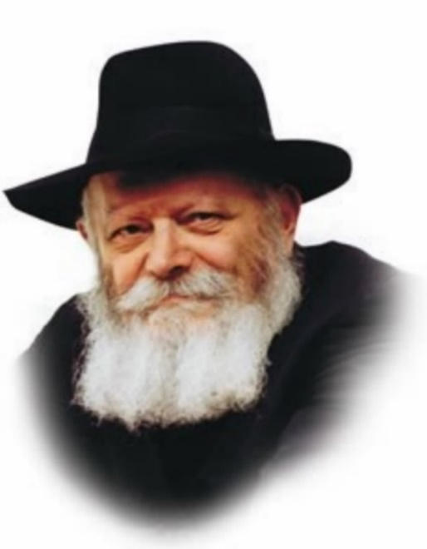

In the Torah, the laws of Shabbat and Yom Tov are enumerated in two different Torah portions, Emor and Pinchas.

At the end of Emor the Torah states, "And Moses declared (vayedabeir) the festivals of G-d to the Children of Israel."

At the end of this week's Torah reading, Pinchas, the Torah states, "And Moses said (vayomeir) to the Children of Israel according to all that G-d had commanded."

What is the difference between "declaring" and "speaking," and what are we to learn from this distinction?

The Torah portion of Emor deals primarily with the prohibition against labor on Shabbat and holidays, and enumerates the particular mitzvot that are associated with each of them, such as matza on Pesach, the sukka and the Four Kinds on Sukkot, etc.

The Torah portion of Pinchas, by contrast, deals primarily with the various sacrifices that are offered on Shabbat and festivals.

The commandments contained in Emor are thus mitzvot that we can perform at all times, regardless of whether or not the Beit Hamikdash (Holy Temple) is standing. Refraining from work on Shabbat and observing the particular mitzvot of each holiday is something that is done by the Jewish people even in exile.

The bringing of sacrifices, however, is dependent on the existence of the Beit Hamikdash. In exile we can only study the Torah verses that refer to them, and recite them in prayer. When a Jew studies these laws, G-d considers it as if he has actually brought that particular sacrifice. For example, when we study the laws of the olah (burnt) offering, G-d considers it as if we had actually offered an olah in the Holy Temple.

When speaking of the obligations and prohibitions that apply in any era, the Torah uses the relatively harsh word "vayedabeir"; when speaking of the sacrifices we can only bring in the times of the Beit Hamikdash, the Torah uses the softer and more gentle term, "vayomeir." In doing so, G-d is entreating us to involve ourselves in the study and recitation in prayer of these laws, even when they are not applicable in the physical sense.

May it be G-d's will that in the merit of our study of the laws of sacrifices, we will very soon be able to actually offer them on the altar of the Third Beit Hamikdash, speedily in our days.

*Reprinted from the Parshat Pinchos 5760/2000 edition of L’Chaim. Adapted from Volume 18 of Likutei Sichot.*

**Thoughts that Count**

**for Our Parsha**

Let the L-rd, the G-d of the spirits of all flesh, set a man over the congregation (Num. 27:16)

Years later, in the times of the Prophet Samuel, the Jewish people would make another request for a Jewish leader when they demanded, "Give us a king." Moses asked G-d to appoint a head "over the congregation," whereas the later request was for a leader who could be easily manipulated by the people. (Degel Machane Efraim)

Who may go out before them, and who may go in before them, and who may lead them out, and who may bring them in (Num. 27:17)

A true Jewish leader is one who does not alter his opinions according to popular demand. Only a leader of such stature has the power to "lead the Jewish people out" of all difficulties, and "bring them in" to the realm of holiness. (Even HaEzel)

*Reprinted from the Parshat Pinchos 5760/2000 edition of L’Chaim.*

**Rav Avigdor Miller on Enjoying**

**The Unique Songs of Each Month**

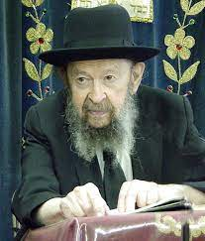

**QUESTION:** You said last week that there’s no such a thing as bad weather. Is it a chisaron if a person enjoys a warm mild day more than a rainy day or a very hot day?

**ANSWER:** When a person enjoys a certain kind of weather he is justified; there’s nothing wrong with that. And not only is he justified but he is a wise man for appreciating it. Of course, if he understands that all weather is good — even though he may not enjoy it, but he understands that it’s a benefit for him, then he’s even wiser.

**Springtime is Not the Best Time for Ripe Fruits**

The fact that a person enjoys spring time more than any other season doesn’t detract from the fact that he can understand that summer is very important. After all, spring-time is not the time when the apples are ripe and when the pears are ripe. In the summer is when they begin turning red. Their cheeks display a color which makes them more and more attractive as they become sweeter and softer. And therefore, despite the heat of summer, he’s able to appreciate it because of the benefit it provides.

So, the fact that one season is more beloved than others, doesn’t detract from the fact that you understand that all seasons are valuable. And so, if you’re a wise man then you learn to enjoy the summertime. Oh yes, the summer has many attractions. You know, there are songs about the summer. They sing about July and August. Then there’s a song about September; Nothing Like September Morning. Ahh, a September morning is pleasure. For every month of the year there are poems.

And we have to learn to sing the songs of every month – not the gentile songs; you can sing your own songs. If we’ll sing all the songs, so we’ll start by singing songs in January – January is very good! The bracing cold of January is a blessing for the world. February? Ah mechayah! Walk outside in February, well dressed, and enjoy the brisk fresh air. March, April, May; every month has its blessing. Nissan, Iyar, Sivan, Tamuz, Av, Elul; every one of them is a time of special brochos. And the person who learns to appreciate them, that’s a שמח בחלקו.

TAPE # E-13 (June 1995)

*Reprinted from a recent email of Toras Avigdor based on Rabbi Miller’s Tape #380 from his classic Thursday night lectures (October 1981)*

**More Thoughts that Count**

Our father. was not in the company of those who gathered together against the L-rd in the company of Korach; but died in his own sin, and had no sons.And Moses brought their cause before the L-rd (Num. 27: 3; 5)

Moses was reluctant to judge the case of the daughters of Tzelofchad, lest their claim that their father was not "in the company of Korach" be misconstrued as a "bribe" that would invalidate his decision. He therefore turned the matter over to G-d, allowing Him to judge it directly. (Minchat Chinuch)

It is a continual burnt offering (olat tamid), which was ordained at Mount Sinai (Num. 28:6)

The words "olat tamid," which mean literally "continually rising upward," allude to the "concealed love of G-d" that is an essential component of the Jewish soul. It is derived from the Jewish people's experience at Mount Sinai, when the revelation of G-d's Essence was so intense that from that point on it became an integral part of their very being. (Ohr HaTorah)

*Reprinted from the Parshat Pinchos 5760/2000 edition of L’Chaim.*

**Rabbi Berel Wein on**

**Parshat Pinchas 5783**

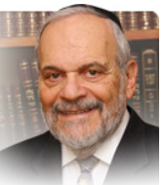

The Torah records for us the genealogy of Pinchas, the true and justified zealot of Jewish history. There are many reasons advanced as to why the Torah felt impelled to tell us of the names of his father and grandfather. Many commentators saw in this an explanation to justify Pinchas’ behavior, while others emphasized that it was an explanation for Pinchas’ reward and of G-d granting him the blessing of peace.

But aside from these insights there is another more general message that the Torah is recording for us. And that is that a person’s behavior affects all of one’s family members, even those of previous generations who may no longer be currently numbered among the living.

A great act of sanctification of G-d’s name such as the one performed by Pinchas enhances the reputations and stature of previous generations as well My rebbe in the yeshiva summed this lesson up in his usual concise and pithy manner: “If both your grandparents and your grandchildren are proud of you and your achievements then you are probably alright in Heaven’s judgment as well.”

Our idea of immortality is based upon generations of our families, both previous generations and later ones. We find vindication of our lives and efforts in the accomplishments of those that come after us and continue our values and faith. We cannot control what children and grandchildren will do, whom they will marry and what type of life they will lead. But innately, we feel that we have a connection to the development of their lives and the actions that they will take.

The Torah emphasizes for us that Pinchas’ zealotry did not come to him in a vacuum. The Torah allows everyone freedom of will and behavior. Neither good behavior nor evil behavior is ever predestined. Yet as medicine has shown us, in the physical world there is an element of physical predestination in our DNA. And this DNA affects our moral behavior as well.

Judaism always envisioned itself not only as a universal faith but as a particular family as well. In our daily prayer service, we constantly recall who our founding ancestors were. We name our children in memory of those who have preceded us. We extol a sense of family and a loyalty to the values that our families represent.

One of the most destructive trends in modern society has been the erosion of the sense of family in the world and amongst Jews particularly. Assimilation means abandoning family and abandoning family certainly contributes to intensified assimilation and loss of Jewish feelings and identity. It is ironic that in a time such as now when most children can be privileged to know grandparents and even great grandparents the relationship between generations in many Jewish families is frayed and weak.

Pinchas comes to reinforce this concept of tying generations – past, present and future – together. It is imperative for us to know Pinchas’ genealogy for otherwise we have no clue as to who Pinchas was and why he behaved as he did in those given circumstances.

Shabat shalom.

*Reprinted from the current website of rabbiwein.com*

**My Family’s Buried Treasure in the Former Soviet Union**

**By Sofya Tamarkin**



***After the Communist Revolution my great-grandfather filled a milk jug with gold coins and buried it in the yard with the hope that one day he’d retrieve it.***

Here’s my family's deepest secret: When I was 8 years old, I overheard my [grandmother Zelda](https://aish.com/my-grandmother-and-the-1922-russian-typhus-epidemic/) telling my parents about a mysterious map that holds a key to our family's fortune. I thought treasure maps were only for pirates! This shocking revelation took place a few months after her father’s passing.

The Communist Revolution of 1917 encouraged its party leaders to cease private property and personal possessions of anyone who was deemed “wealthy” by socialists' standards. The new Soviet philosophy supported collective ownership. Everything my great-grandfather David earned throughout years of hard work with his father in a kosher slaughtering business was now owned by the government.

Party demands were not to be ignored. Disobedience resulted in devastating consequences, imprisonment, exile to Siberia and even death. David knew that keeping his family's hard-earned money was not an option.

As our family's legend has it, David filled a milk jug with gold coins and buried it in the yard. He believed that one day life would return to “normal” but until then family fortune would be safer buried in the ground.

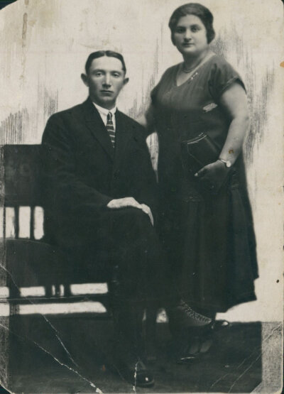

***David with his wife Golda in the early 1920s***

David didn't trust his memory and so he drew a detailed map to aid himself in retrieving it one day. Years went by and for over eight decades of David's life, Communists continued to rule the country. Atheism penetrated Soviet society with a destructive mindset of communal apathy.

Religious observances were a crime punishable by law. Children no longer believed in G-d or knew of a world where individuality was celebrated and encouraged. People spent their days in long lines for food, clothes and basic necessities.

Personal wealth was a thing of the past. Everyone was deemed “equal” in the Soviet Union reality, and many forgot how to dream.

But David never gave up hope. Right up until his passing in June of 1985, my great grandfather continued to hold on to his treasure map, praying for a better future for his family.

On his deathbed, David gave the map to his three daughters as a token of faith, believing that his family’s legacy will eventually be reclaimed.

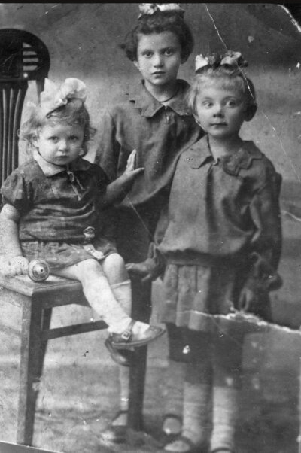

***David’s three daughters. My grandmother Zelda is standing on the right.***

Despite the enormous influence of Soviet society, David never lost connection to his Jewish heritage. He secretly ate matzah on Passover and fasted on Yom Kippur. Up until his death, David privately reassured his children and grandchildren that Communism will eventually crumble from within their atheistic mission.

**A New Life in the U.S.**

While David didn't live to see his predictions actualize, his children did. In 1989, [President Gorbachev](https://aish.com/mikhail-gorbachev-in-his-own-words/) allowed Soviet Jews to leave the country. We were one of the first families who emigrated from our city of Saratov to the United States.

What happened to the jug filled with gold coins?

Before coming to the United States, my family was closely followed and monitored by the KGB agents. Emigration out of the Communist country was a new idea and a taboo subject. Any actions that might be deemed as suspicious would halt our exit.

**My parents decided that freedom was infinitely greater than any material treasure.**

My parents understood that digging for treasures would immediately draw unnecessary attention. They decided that freedom was infinitely greater than any material treasure.

While the jug was never reclaimed, our family's heritage was. Since our arrival in the United States, we have been fortunate to celebrate our Jewish identity. We worked hard at earning a living, learning English and adjusting to the new life in the United States. We created many memories, our own family “treasures” of connection and purpose. My grandmother Zelda did merit to see a better world, just as her father hoped. She lived for three more decades after immigrating to Philadelphia, proud of her Jewish identity.

Growing up in the former Soviet Union, I wasn't allowed to question atheistic ideas. Fortunately, at the age of 13, I received a blessing from the Lubavitcher Rebbe. I remember seeing a reflection of my G-dly soul in his eyes. Since that time, I began to view my Soviet upbringing as an external cover hiding my spiritual light. David's buried jug reminds me of my own inner spark hidden within, and gives me strength.

I don't understand G-d's plan as to why my family had to struggle under the Communist regime. Yet, I am beyond thankful to know that my true essence was never diminished and can always be uncovered and reclaimed.

**Unlikely that the Jug of Coins Has Survived**

After hiding underground for over 100 years, it's unlikely that the jug remains in its original spot. My great grandfather's house was demolished many decades ago and tall apartments were built in its place. I suspect that the jug with coins was cemented into the foundation of one of the high-rises or perhaps found by a construction worker.

I feel a sense of sadness that David's hard-earned fortune was never uncovered and its map left behind, but I remind myself that I found an even more valuable treasure map – the Torah. It guides me to uncover gems of priceless Jewish wisdom and is a treasure more precious than gold.

*Reprinted from current website of aish.com*

**Yichud When**

**Husband is in Town**

**By Rabbi Chaim Hillel Raskin**



When does the husband's presence in town permit yichud? The prohibition of yichud precludes members of opposite genders being secluded for any amount of time unless a valid mitigating factor is present, such as an “open door”. Another permissible situation is if the woman is married and her husband is “in the city” at that time (“baalah ba’ir”).

Poskim debate the logic behind this heter: Some understand that the fact itself that the husband is within the city makes his wife subconsciously nervous to act improperly even if it is unlikely for him to show up (e.g., he is at work or hospitalized).

Others argue that this only applies if the husband may actually arrive unexpectedly at any moment. In practice, we follow the stricter opinion that necessitates a real possibility for the husband to show up. Yet, in certain situations, we may rely on the very fact the husband is local in combination with additional factors.

Even according to the accepted stricter view, “baalah ba’ir” is effective even if the door is locked and the husband does not have the key with him. Although this would not constitute “pesach pasuach,” it is enough for the woman to be concerned.

**Husband Must Know Where His Wife is**

If the woman is away from the home, the husband must – according to the stricter view – be made aware of her whereabouts so that he can realistically show up. If a woman visits a male doctor, even if the husband knows the address, he cannot enter if the door is locked, so it must be left ajar or at least unlocked.

Some poskim require bringing along another woman whose husband is also in the city, and the double fear is stronger grounds to permit yichud. Alternatively, if a female nurse remains in the room together with the doctor, the door may be closed if left unlocked.

The heter does not apply to a man if his wife is in town since a man is more likely to sin regardless. When a woman is relying on baalah ba’ir to be alone with a Jewish man, she must tell him this, so that isn't doing something which he believes to be forbidden.

**A Jewish Man Cannot be Secluded**

**with a Non-Jewish Woman**

A Jewish man may not be secluded with a non-Jewish woman even if her husband is in town. Yet, if the woman is Jewish, even if she only had a civil marriage, the heter of “baalah ba’ir” does apply.

Baalah ba’ir on its own does not permit a woman to be alone with adopted sons with whom there is a close relationship. Although “baalah ba’ir” is a legitimate heter, it is a midas chassidus not to rely on it wherever possible.

*Reprinted from the Parshas Pinchas 5782 edition of The Weekly Farbrengen.*